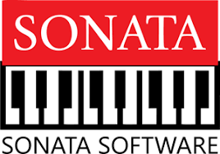

**Generative AI Document**

**GENERATIVE AI L2**

**Prepared By**

Amareswari Palle

# **Introduction**

The Chat Search Bot is a user-friendly web application built with Streamlit python library. It helps you unlock insights from your documents by combining powerful search and AI-powered question answering.

* Upload various document formats: PDFs, text files, Excel sheets, Word documents, and PowerPoint presentations.
* The application seamlessly processes your uploaded documents, making them readily searchable.
* Leverage the built-in search functionality to quickly find the information you need within your documents.
* Go beyond simple search with the integrated AI assistant. Ask questions in natural language, and the bot will retrieve relevant answers based on the uploaded document.

**Requirements**

1. Code Editor: VS Code, Sublime Text, PyCharm etc.
2. Python Installation (latest version)
3. Dependencies: PyPDF2, Pandas, Streamlit, pptx, docx, langchain- etc.

**Design Chart:**

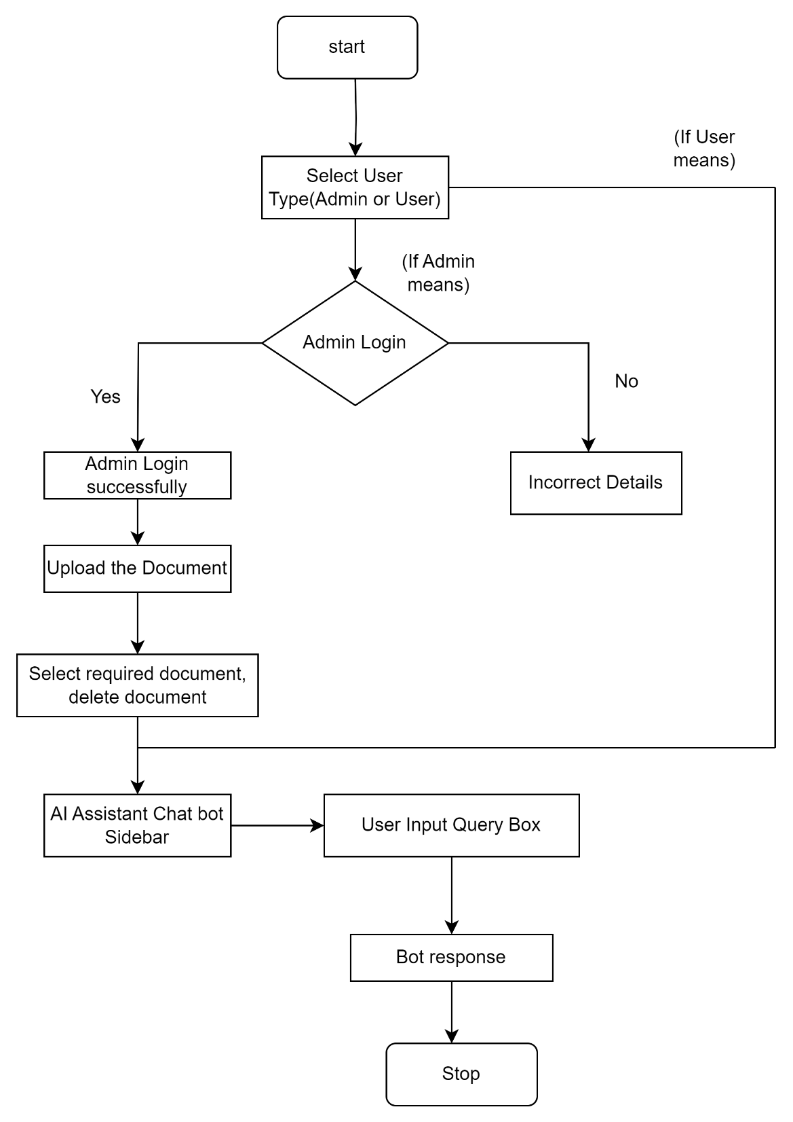

**Explanation:**

* The application starts.
* Users are prompted to indicate their role: Admin or User.
* If identified as an Admin, they are directed to the Admin Login screen to enter their mail and password.
* Upon successful authentication, Admin functionalities are activated, allowing access to document upload and management features.
* Admins can upload documents (like PDF, text file, Excel sheet, Word document, or PowerPoint presentation).
* They can upload one or more documents and perform actions such as selecting or deleting documents. Admins also can engage with AI Assistant sidebar.
* Users are presented with a user interface indicating no documents have been uploaded.
* Users can engage with the AI Assistant sidebar.
* Users input queries, click the "Send" button, and receive responses from the bot.
* Finally, the application stops**.**

**Implementation:**

* This application is developed using Python and Streamlit library for the web interface.
* It relies on several libraries for document processing, including PyPDF2 for handling PDFs, python-docx for Word documents, Pandas for Excel sheets, and python-pptx for PowerPoint presentations.
* Document processing involves multiple steps such as text extraction, document chunking, and text indexing.
* OpenAI's API key embeddings and FAISS are utilized for text indexing and similarity search.
* The question-answering system is seamlessly integrated using OpenAI's language models.
* User authentication functionality is implemented using Streamlit's input widgets.

**How to access Chat Search Bot:**

1. **To Launch the Bot:** Run the Code (streamlit run <filename>.py)
   * It will Open your web browser and navigate to [Bot URL]. You'll find the Chat Search Bot interface.
2. **Choose Required Role:** They are 2 roles.
   * 1. Admin 2. User
   * Select either "Admin" or "User" based on your access level.

If you choose **“Admin”**

1. **Admin Login (if applicable):** 
   * If you are an administrator, enter the user mail "manju123@gmail.com" and password "Manju@300602" to authenticate. (**Note:** This is for secure authentication purposes). Click the Enter/login button to proceed.
2. **Upload Documents (Admin only):**

* Once logged in as an Admin, you can upload documents in various formats: PDF, TXT, DOCX, XLSX, or PPTX.
* Drag and drop files directly onto the interface or use the "Browse Files" option.

1. **Ask Your Questions:**
   * Enter your query in the designated field.
   * Click "Send" to send your question to the AI Assistant.
2. **Get Answers from the Assistant Bot:**
   * The AI Assistant will analyze your question and upload documents, then provide a response.
   * The conversation history including your questions and the bot's answers.

**7.Manage Documents (Admin only):**

* + Select the checkboxes next to documents you want to delete.
  + Click "Delete Documents" to remove them from the system.

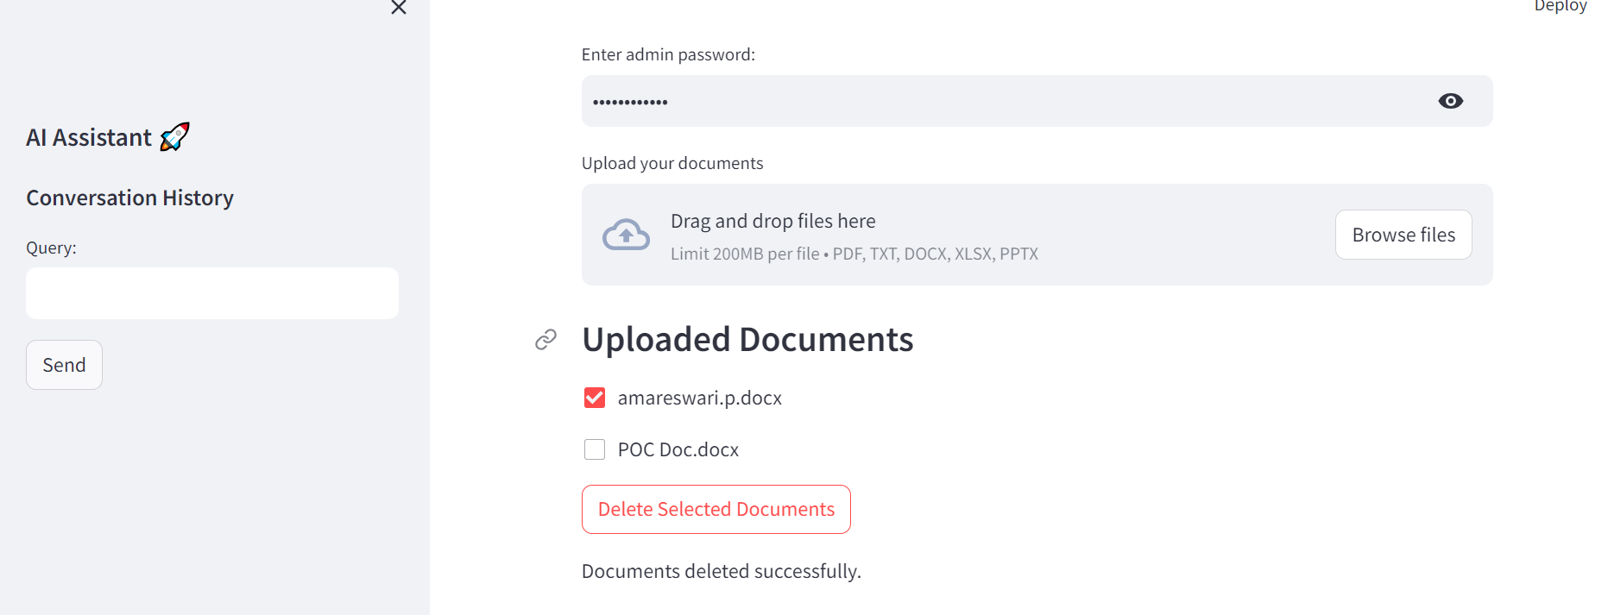

If you choose **“User”**

If you're logging in as a normal user, you'll be able to view the list of uploaded documents.

1. **Ask Queries:**

* Enter your query into the input field on the right-hand side.
* Click the "Request" button to submit your query.

1. **Get Answers from the Assistant Bot:**
   1. The AI Assistant will analyze your question and upload documents, then provide a response.
   2. The conversation history including your questions and the bot's answers.

**Conclusion:**

The Chat Search Bot is a Streamlit-based application that enables users to search documents and get answers to their questions using AI. It supports both admin and normal user roles, allowing for document management and interaction with the AI assistant. Key features include user authentication, document upload, text processing, and AI-powered question-answering. It provides a user-friendly platform for efficiently searching documents and obtaining relevant information.